Genome Based Multi-antigenic Epitopes Vaccine Construct Against Staphylococcus hominis Using Reverse Vaccinology and Biophysical Approaches

By:
Mahreen Nawaz

REG No: AUP-19FL-BSBIOT-15883

Supervised by
Dr. Sajjad Ahmad
Thesis report Submitted to the Department of Health and Biological science,
Abasyn University in Partial Fulfillment of the Requirements for the
Degree of Bachelor of Science in Biotechnology

Faculty of Life Sciences,
Department of Health and Biological Sciences,
Abasyn University Peshawar Campus,
Khyber Pakhtunkhwa
October, 2023
DEDICATION
I dedicate this dissertation to my parents. I hope that this achievement will complete the dream that they had for me all those many years ago when they choose to give me the best education they could. Also, I dedicate this effort of mine to my loving and caring Sisters: Aiman Zeeshan, Shawana Nawaz and my mamo whose affection, love, support and encouragement make me able to get such success and honor.
APPROVAL CERTIFICATE
This study, entitled “Genome Based Multi-antigenic Epitopes Vaccine Construct Against Staphylococcus hominis Using Reverse Vaccinology and Biophysical Approaches” Submitted by Mahreen Nawaz to the Department of Health and Biological Sciences, Abasyn University, Peshawar, Pakistan, is accepted in its present form as satisfying the thesis requirements for the Degree of Bachelor of Science in Biotechnology.
Mahreen Nawaz _______________________
(Student)
Examination Committee
- External Examiner: Mr. Asad Ullah
(Lecturer Department of health and biological sciences)
Signature: _________________

- Internal Examiner: Dr. Sajjad Ahmad
Signature: _________________

Supervisor Name: Dr. Sajjad Ahmad Signature: _________________

Name of Dean/HOD: Dr. Zoobia Afsheen Signature: _________________
Table of Contents
List of Tables i
List of Figures ii
ACKNOWLEDGMENTS iv
Abstract v
1. Introduction 1
2. Aims and Objective 3
3. Literature Review 4
4. Methodology 7
4.1. Pre-Screening: 9
4.2. Vaccine candidate prioritization: 9
4.3. Prediction of Immune cells epitopes: 10
4.4. Epitopes Prioritization: 10
4.5. Multi Epitope Vaccine Designing: 10
4.6. Multi epitope Vaccine processing: 10
5. Results 13
5.1. Sequence Retrieval from NCBI: 13
5.2. Pan-Genome Analysis: 13
5.3. CD-Hit Analysis: 14
5.4. Sub-Cellular Localization: 15
5.5. Virulence Check: 16
5.6. Transmembrane Helices and Physiochemical Properties Analysis: 16
5.7. Homology Check against Probiotics: 17
5.8. B and T-Cells Epitope Prediction: 17
5.9. Epitope Prioritization: 21
5.10. Vaccine construction: 22
5.11. Multi Epitope Vaccine Construct Processing: 25
6. Discussion 39
7. Conclusion and Recommendations: 41
8. References 42

List of Tables
Table 1: Bacterial strains used in the process. 13
Table 2: Details of Pan-genome analysis. 14
Table 3: List of virulent proteins. 16
Table 4: Vaccine candidate prioritization 17
Table 5: B-Cell epitopes 19
Table 6: T-Cell epitopes 19
Table 7: PATCHDOCK results for MHC I. 25
Table 8: PATCHDOCK results for MHC II. 26
Table 9: PATCHDOCK results for TLR4. 28
Table 10: FireDock results for MHC I 29
Table 11: FireDock results for MHCII 30
Table 12: FireDock results for TLR4 30
Table 13: Loop modelling for the residues. 35
Table 14: Binding free energies calculations. 38

List of Figures
Figure 1. Schematic view of designed computational framework for screening broad-spectrum vaccine against S.hominis in reference proteome followed by epitope prioritization, Multi-Epitope Vaccine (MEV) construction and MEV processing. 7
Figure 2. The overview of screening core proteins from different steps. 14
Figure 3. List of 11 shortlisted epitopes that are non-toxic, non-allergenic, antigenic and water-soluble 20
Figure 4. A visualized view of MEV construct Yellow color represent GPGPG linkers, blue color represent Cholera toxin B-subunit, red color (EAAAK linkers) and orchid color represent epitopes. 21
Figure 5. The schematic description of vaccine construct, Green represent Cholera Toxin B-subunit (adjuvant) link with epitopes through EAAK linkers and blue color represent epitopes link to each other with GPGPG linkers. 22
Figure 6. Top 3 modeled and visualized complexes of MHC I, MHC II and TLR4 respectively. 30
Figure 7. View of our MEV DNA sequence ligated into pET-28a(+) vector 32
Figure 8. Original and mutant structure of the MEV construct. The yellowish highlighted area in the mutant shown introduction of disulfide bonds into the structure. 33
Figure 9. RMSD plot of our multi epitope vaccine construct. 36

List of Acronyms and Abreviations
AMBER Assisted Model Building with Energy Refinement 11, 48
BCR B-cell receptor 20
BLASTp Basic Local Alignment Search Tool for Protein 8, 14, 16
BPGA Bacterial Pan Genome Analysis 12, 42
CAI Codon Adaptation Index 10
CONs Coagulase-Negative Staphylococci 1
E. coli Escherichia coli v, 48
EBOV Ebola Virus 6
H. pylori Helicobacter pylori 2, 6
HAIs Hospital Acquired Infections 1
HPIV Human Parainfluenza virus 4, 47
IEDB Immune Epitope Database 1, 9, 43
MD simulation Molecular Dynamic simulation 10, 35, 37, 39
MenB Meningococcus B 1
MM/GBSA Molecular mechanics with generalised Born and surface area solvation 11, 49
MM/PBSA Molecular Mechanics Poisson-Boltzmann Surface Area 11
NCBI National Center for Biotechnology Information 6, 11, 16
PGRV Pan Genomic based Reverse Vaccinology 1
RV Reverse vaccinology 1
SARS61 CoV-2 Severe Acute Respiratory Syndrome CoronaVirus 2 5
SCC Staphylococcal Cassette Chromosome 1
TCR T-cell receptor 20
TLR Toll Like Receptor v, 4, 6, 36
VFDB Virulent Factor Database 8, 14

ACKNOWLEDGMENTS
I am grateful to Allah, whose blessings enabled me to achieve my goals. Tremendous praise for his holy prophet. Hazrat Muhammad (P.B.U.H). who is forever a torch of guidance for knowledge seekers whole humanity.
I would like to thank my research supervisor Dr. Sajjad Ahmad for sharing with me his experience, knowledge, moral support and guidance throughout my study. I gratefully acknowledged him who equipped me with this capacity of learning, and dedication to pursue my study.
I am also grateful to my teachers all teachers of Abasyn University for their guidance who always say yes to give right and appreciable suggestions. I am also grateful to Dr. Zobia Afsheen Assistant Professor and Head of Department of Microbiology and Biotechnology who always supported me whenever I need of support. I am grateful to all teachers and staff for their unconditional guidance and help at every stage of my research during my stay at university.
My unlimited thanks to Lab staff, seniors and friends during my BS (Biotechnology). for their pleasant company, conversations, help, guidance and friendship.
May Allah bless you all, Ameen.

Genome Based Multi-Antigenic Epitopes Vaccine Construct Against Staphylococcus hominis Using Reverse Vaccinology and Biophysical Approaches
Mahreen Nawaz and Dr, Sajjad Ahmad
Department of health and Biological Sciences,
Abasyn University, Peshawar.
Session 2019-2023

Abstract
Staphylococcus hominis is Gram positive bacteria from Staphylococcus genus and a member of coagulase-negative staphylococci, because of its opportunistic nature and ability to cause life-threatening bloodstream infections in immunocompromised patients, Gram positive and opportunistic bacteria has become a major concern in the medical community. It also drawn the attention of scientists due to evaluation in immune evasion tactics and the development of multi-drug resistant strains. This urged the need to explore novel therapeutic approaches as an alternative to antibiotics. The current study aims to develop broad-spectrum multi-epitope vaccine to control the ailed infection and reduce the burden on health care systems. A computational framework was designed to filter out the immunogenic potent vaccine candidate. This framework consists of pan genomics, subtractive proteomics and immunoinformatic approaches to prioritize vaccine candidates. A total of 12285 core proteins were obtained with pan-genome analysis of all the strains. Screening of the core proteins results in the selection of only two proteins for the next epitope prediction phase. A total of 11 B-cell derived T-cell epitopes were selected that met criteria of different Immunoinformatic approaches such as allergenicity, antigenicity, immunogenicity, and nontoxicity. A vaccine construct was formulated using EAAAK and GPGPG linkers and Cholera Toxin B-subunit. This formulated vaccine construct was further used for downward analysis. The top 3 refined docked complexes docked with MHC I and II and TLR4 receptors were selected, proving the best binding potential of vaccine with immune receptors. The docked complex was loop refined, improved its stability through disulfide engineering. For efficient expression in our protein, the codons were optimized as per the usage pattern of the E. coli (K12) expression system, followed by molecular dynamic simulations. The results indicate the best intermolecular bonding between immune receptors and vaccine epitopes and that they are exposed to the host immune system. In the end, binding energies were calculated to confirm the binding stability of docked complexes. The aim of this work was to provide a manageable list of immunogenic and antigenic epitopes that could be used as potent vaccine candidate for experimental in vivo and in vitro studies.

Introduction
Staphylococcus hominis (S. hominis) is gram-positive bacteria, nosocomial pathogen and a member of the staphylococcus genus consisting of spherical cells (Abdalla et al., 2013). Despite from the harmless commensal to human and animal skin, it potentially caused bloodstream infections in immunocompromised patients. Among CONs, S.homins is one of the three most identified isolates from the blood of hospitalized patients (Mendoza-Olazarán et al., 2013). Studies reported that among staphylococcal infections, 15 % are caused by S. hominis and also associated with several other diseases including petronitist, osteomyelitis, bone and joint infection, cancer and bacterial Meningitis (Voineagu et al., 2012) (Abbas et al., 2020) (Szczuka et al., 2018) (Ahmed et al., 2017) (Sunbul et al., 2006). S. hominis is a multidrug-resistant bacterium that is resistant to a class of antibiotics known as lactams (methicillin, tetracycline, erythromycin, novobiocin, and Oxacillin). These were once effective against them, now replaced by vancomycin. The S. hominis sub-specie novobiosepticus now show some resistance to vancomycin. Staphylococcal Cassette Chromosome (SCC), mobile genetics element, have genes that code for antibiotic resistance proteins (Hanssen & Sollid, 2007). Apart from the classical immunization methods and pasture’s rule of vaccinology, the genome sequencing of various microbes revolutionized vaccine development, allowing scientists to design vaccines using various computational approaches, tools, and software. Reverse vaccinology (RV), a new computational approach, was used to develop first computationally designed vaccine against Meningococcus B (MenB), a pathogen which caused 50% of meningococcal Meningitis worldwide. (Donati & Rappuoli, 2013) (Masignani et al., 2019). Although, RV is an effective approach to screen the immunogenic targets of pathogen’s genome but the pan-genome is merged with RV termed as Pan Genomic based Reverse Vaccinology (PGRV) for the purpose to screen the intraspecific diversity of bacteria and its broad-spectrum applications. Because of the emergence of AR in S. hominis and the lack of a licensed vaccine against this specific bacterium, the risk of HAIs is increasing exponentially. Based on this, current study is design to explore novel therapeutics multi-epitope vaccine construct via applying a computational framework using subtractive proteomics, pan-genome and RV. To prioritize promising vaccine candidates, we used the bacterial pan-genome of S. hominis and its subspecies, as well as Immunoinformatics and Reverse Vaccinology approaches. Online server the Immune Epitope Database (IEDB) were used to find B and T cell epitopes. All of the selected epitope sequences were further screened computationally to determine their immunogenicity, toxicity, allergenicity, and solubility. Adjuvants and linkers were combined with these sequences to efficiently boost immune responses. The construct design is then modelled using 3Dpro of protein scratch predictor. Docking and molecular dynamic simulations were used to predict the binding affinity to B and T cell epitopes. The stability of molecules was predicted by estimating the complex's binding free energies. Since the RV approach uses several in silico filters to select high probability proteins as vaccine candidate from the coding DNA of organism, we are assured that the finding of this study will aid in the fast and efficient development of vaccine against S. hominis by applying of more experimental testing including in vitro and in vivo.

Aims and Objective
Based on its adherence proteins, the present study seeks to develop a multi-epitope vaccine against S.hominis. Objective of the study are:
- To retrieve the virulence factors (adhesive proteins) and process it to obtain multi epitopes.
- To construct a vaccine candidate and check its binding efficiency with human immune receptors i-e TLR4, MHC-I and MHC-II.
- To produce the vaccine through in-silico cloning.

Literature Review
Z. Khan et al. (2023)constructed a multi-epitope vaccine against Human parainfluenza virus (HPIV) based on HPIV-1 fusion glycoprotein antigen. These antigens play a vital role in adhering to the epithelial cells of the respiratory tract. Protein processing was done to determine B-cell and T-cell epitopes. To build the vaccine, the B cell epitopes were linked with the peptide EAAAK, the MHC-1 epitopes were linked with the peptide GPGPG, and the MHC-2 epitopes were linked with the peptide AAY. These epitopes were selected because they passed the antigenicity, allergenicity, and toxicity profiles. In order for the vaccine to properly elicit an immune reaction, the adjuvant (50S ribosomal protein L7/L12) was also added to the amino terminus. The vaccine's tertiary structure was predicted, and the structure was verified using Ramachandran plot analysis and Z-score, then the vaccine was docked with the TLR-8 receptor. Utilizing molecular dynamic models, the stability of the vaccine and TLR-8 docked complex was assessed. Finally, using the pET-28a (+) vector, the vaccine's reverse translated sequence was cloned. This could be a beneficial effort for the creation of an HPIV infection vaccine.
Rahman et al. (2023) created a multi-epitope vaccine for research to protect against the toxins secreted by S. aureus, such as staphylococcal enterotoxin A (SEA), staphylococcal enterotoxin B (SEB), and toxic-shock syndrome toxin (TSST-1). These toxins play contributing roles in the pathogenesis and killing of the host cell. Creating a vaccine based on these proteins will have promising outcomes to suppress its pathogenicity. These chosen proteins were used to determine linear B-lymphocyte, cytotoxic T-lymphocyte (CTL), and helper T-lymphocyte (HTL) epitopes. Linkers were used to connect the epitopes, and the adjuvant Human Beta-Defensin-3 (HBD-3) was introduced to the vaccine construct's N-terminus. It was discovered that the finished vaccine had antigenic and non-allergenic properties. The immune-stimulating potential of the developed vaccine construct and the viability of its cloning in the pET28a(+) vector using the E. coli expression system were anticipated by in silico immune simulation and cloning.
Sanami et al. (2022) Worked on an in silico framework to construct multi epitope vaccine against HPV 16/18 (Human Papilloma Virus). It causes cervical cancer the fourth most common factor of leading deaths in women. He uses E5 E7 proteins of HPV 16/18 for T-cell epitope prediction. The epitopes are highly antigenic, non-toxic, water soluble and non-allergic. These epitopes are properly linked and adjuvanted with C-terminal fragment of mycobacterium tuberculosis heat shock proteins 70 (HP70). The 3d structure f vaccine was predicted and refined. The stability of protein structure was checked by creating and analyzing the Ramachandran plot. Molecular docking show good interaction with TLR4 and stability was confirmed by molecular dynamic simulations. The vaccine was further optimized for codon adaptation according to the E. coli (K12) strain’s protein expression system and then cloned in pET-28a(+) expression vector.
Arumugam & Varamballi, et al. (2021) performed a study by constructing a multi-epitope vaccine against the envelop protein of Kyasanur forest disease virus (KFDV). This virus is spread via tick and is fatal for human beings. Epitopes were predicted from the envelope protein based on B-cell and T-cell. Two vaccine candidates (VC1 and CV2) were predicted and structurally validated. Docking analysis of vaccine candidates with toll-like receptor-2 (TLR-2) by ClustPro and PatchDock revealed strong affinity between VC1 and TLR2. Ligplot tool was identified the intermolecular hydrogen bonds between vaccine candidates and TLR-2, iMOD server confirmed the stability of the docking complexes. JCAT sever ensured cloning efficiency of both vaccine constructs and in-silico cloning into pET30a (+) vector by SnapGene showed successful translation of epitope region. IMMSIM server was identified increased immunological responses.
Faiza et al. (2020)conducted a study by designing multi-epitope vaccine based on SARS61 CoV-2 and SARS-Covid spike glycoproteins against corona virus. These spike glycoproteins are known as active participants in the pathogenesis of the infection. These spike proteins were processed for B-cell, Helper T-cell and cytotoxic T-cell epitopes prediction and was these epitopes were analyzed and linked together via different linkers. Adjuvant was added and vaccine candidate was structurally predicted and produced via in-silico cloning.
Hajighahramani et al. (2017) developed a Staphylococcus aureus multi-epitope vaccine based on Alpha-enolase, Clumping Factor A, and Iron Surface Determinant B. These proteins play many vital roles in the pathogenesis of the infection. Constructing an epitope-based vaccine will be effective to halt the progression of infection. T-cell, B-cell, and interferon-gamma epitopes had been predicted. The high-ranked epitopes from the aforementioned antigens were chosen after epitopes were examined. The appropriate linkers were used to combine the adjuvant and the chosen epitopes. The chosen and verified protein structure came next. The vaccine was docked with TLR-2 to test its ability to attach, and molecular dynamic simulation studies were carried out to verify its stability and behavior inside the body.
Meza et al. (2017) conduct research on designing a multi-epitope vaccine against H. pylori based on urease B (residue 148–158, 188–198), cytotoxin-associated gene A (residue 584–602), neutrophil activating protein (residue 4–28), vacuolating cytotoxin gene A (residue 63–81), H. pylori adhesine A (residue77–99), heat shock protein A (residue 32–54) and gamma glutamyl transpeptidase (residue 271–293). B-cell and T-cell epitopes were predicted for the virulence factors and were refined by different analysis. Cholera b toxin was applied as an adjuvant, and the filtered epitopes were connected by linkers. Structure was predicted and the chimeric protein was expressed in Escherichia coli BL21 and the serology analyses indicated that the protein produced exhibit immune-reactivity.
Dash et al. (2017) Conduct research on designing multi epitope vaccine against Ebola virus (EBOV). It is a lethal virus causing more than 24 epidemic outbreaks up to date. Using immunoinformatics, molecular docking and simulation techniques he predicted the B and T- cell epitopes from the antigenic protein sequence glycoproteins of EBOV. The peptide (HKEGAFFLY) had great interaction with HLA-A*32:15 with high structural stability and have good conservancy of 83.85% and having great population coverage. Above all the he expected that the epitopes are anticipated to offer long term immunity against EBOV.

Methodology
The proteomic data of S. hominis was retrieve from the genome database of NCBI. Those were then filtered out and prioritized by many immunoinformatics tools for potential vaccine candidate. This prioritization is based on the criteria given in the literature (Ismail et al., 2021). The schematic view is given in Fig 1.

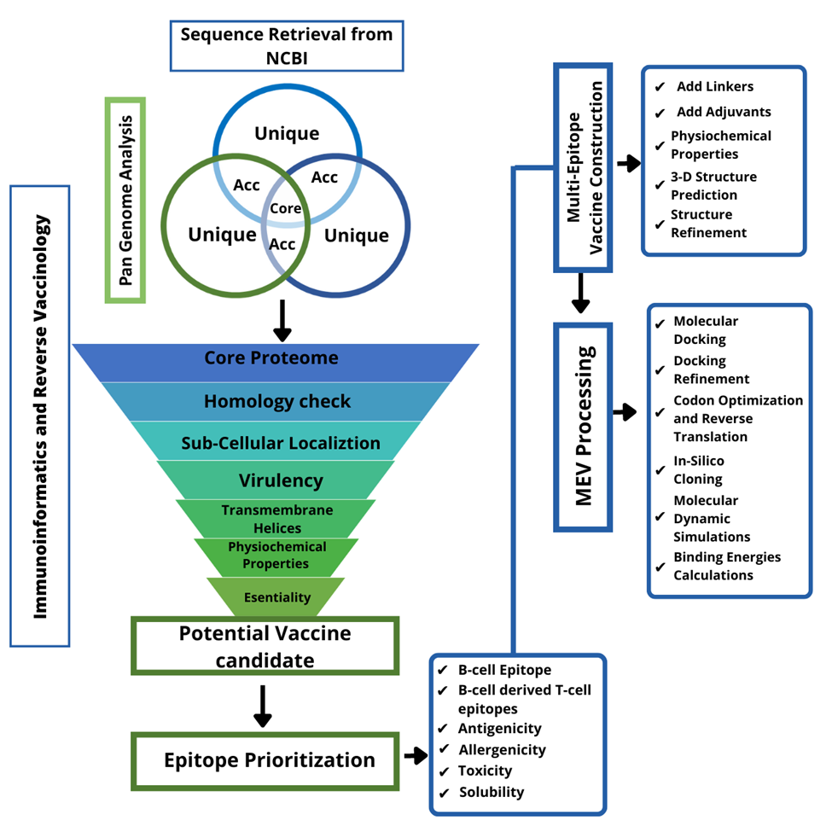
Figure 1. Schematic view of designed computational framework for screening broad-spectrum vaccine against S.hominis in reference proteome followed by epitope prioritization, Multi-Epitope Vaccine (MEV) construction and MEV processing.

Pre-Screening:
In this phase, we screen for the protein conserved among all of the strains. We did pan-genome analysis and screened out the core genome sequence. The redundant proteins aren’t the potent immunological proteins because of their poor conservation across the genomes of whole strains (Al-Megrin et al., 2022). They aren’t part of the core genome. The non-redundant proteins in the core sequence were predicted using the CD-hit web server with a sequence identity threshold of 90%, with keeping all the values by default (Jones et al., 2020). The non-redundant proteins were subjected for sub-cellular localization check. Proteins localized at the surface of pathogen or secrotome are the vital proteins for vaccine as they are in frequent contact with the host and cause infections (Asad et al., 2018). The antigenicity of these proteins can be easily recognized by host immune system and trigger an immune response. Proteins localized at the inner and outer membrane, periplasmic spaces and secretory proteins were selected for the next phase. The proteins with multiple and unknown localization were discarded (Ismail et al., 2020).

Vaccine candidate prioritization:
The pathogenic secretome and exproteome were further filtered to find those proteins associated with pathogenesis. The screened proteins at this stage were BLASTp against the Virulent Factor Database (VFDB) for screening virulent proteins with a sequence identity ≥30% and bit score ≥100 (M. T. ul Qamar et al., 2021). The virulent proteins were further processed for physiochemical properties. The physiochemical characterization was done through an online tool called ProtParam. This tool predicts the computation of parameters like instability index, molecular weight, estimated half-life, atomic composition, aliphatic index, theoretical PI etc. (BAWA et al., 2022). The key factors to evaluate were the instability index and molecular weight. The proteins with an instability index value of less than 40 and molecular weight of less than 100 kDa were considered the best choices for vaccine candidate. The next step is to examine the protein for transmembrane helices. Only proteins with 0 and 1 transmembrane helices were selected (Alberts et al., 2002). To eliminate the risk of inhibition of certain beneficial bacteria, the homology of proteins was checked against probiotics Lactobacillus species like L.rhamnosus (taxid: 47715), L.casei (taxid: 1582), and L.johnsonii (taxid: 33959) (Ullah et al., 2021). For this, a BLASTp search was performed against and selected only those proteins, that had no significant similarity (Hu & Kurgan, 2019).

Prediction of Immune cells epitopes:
At the Immune Epitope Database (IEDB) the Bepipered Linear Epitope prediction with a value 0.5 was used to predict linear B-cell epitopes (Ras-Carmona et al., 2021). The B-cell epitopes were subsequently used for T-cell antigenic determinants using IEDB Antigenic determinants Analysis to find subsequences that bind with MHC (I & II) alleles (Dhanda et al., 2019). The method employed for this prediction was IEDB 2.22 where the peptides are sorted based on percentile score, with lower percentile score having the higher biding affinity (Bordbar et al., 2020).

Epitopes Prioritization:
In this phase, we further process the proteomic sequences of epitopes for antigenicity, allergenicity, toxicity, and solubility prediction (Soltan et al., 2021). The antigenicity was checked using VaxiJen 2.0 (Naveed et al., 2022). The antigenicity of the epitope was checked through AllerTop 2.0 (Kumar et al., 2020). The toxicity was predicted by using a bioinformatics tool called ToxinPred (Sharma et al., 2022). The screened proteome was further categorized as water soluble or non-soluble using Innovagen.

Multi Epitope Vaccine Designing:
The peptide vaccines have weak immunogenicity, which can be overcome by using immunodominant epitopes (adjuvants) (Lim et al., 2021). The multi epitope peptide vaccine has series of overlapping epitope protein sequences, that can be assembled and combined using GPGPG linkers (Chauhan et al., 2019). The 3-D structure of the construct was simulated using 3Dpro from the web server Scratch Protein Predictor (Das et al., 2021). Furthermore, the structure was refined using Glaxy Refine of the Galaxy web server (Shehzad et al., 2022).

Multi epitope Vaccine processing:

Molecular Docking:
Molecular docking plays a vital role in vaccine construct designing to interpret the binding affinity of the vaccine construct with the host’s immune receptors (Ghosh et al., 2021). An effective immune response will be activated when the MEV efficiently binds to with the host’s immune receptors. Molecular docking of the designed vaccine construct with immune receptors was performed using the web server PATCHDOCK, which allows docking of two interacting molecules based on the shape interrelation principles (Mahmud et al., 2021). A blind docking strategy was applied with immune receptors TLR4, MHC I and MHC II molecules (Alharbi et al., 2022). The input clustering RMSD and complex type were set as defaults. The docked complexes were then refined using FireDock on the same web server. The FireDock re-ranked the docking complex results by filtering out all the clashes and molecular conformational errors (Guest et al., 2021). The topmost selected complexes were then visualize using UCSF chimera 1.16.

In silico cloning and codon optimization:
To get efficient expression of the vaccine construct in the E.coli expression system, the sequence was reverse translated and optimized for codon usage (Kar et al., 2020). The vaccine sequence was reverse translated and improved by utilizing the JCAT (java codon adaptation tool). It calculates the CAI (codon adaptation index) and the GC content of the sequence. Ideally, the CAI should be 1 and GC content should be around 30-70% (Jalal et al., 2022). The sequence was then cloned into pET-28a(+) expression vector of E.coli (K12) using software called SnapGene (Srividya et al., 2020).

Disulfide Engineering:
The MEV construct was engineered using a disulfide engineering approach for structure stability. The disulfide links were introduced into the structure using the bioinformatics tool Design2.0 (Deng et al., 2020).

Molecular Dynamic simulations:
MD simulation is a computational framework to evaluate the structural dynamics of biomolecules at atomic resolution with different environmental conditions. A software called AMBER20 was used in the process (Case et al., 2021). This process has three phases
- System preparation
- Pre processing
- Production
In the first phase, the top 3 docked complexes of MEV were prepared using the antechamber program. The libraries and parameters were set. Afterward, the complexes were added to the solvation box (TIP3P size 12 Å) by the leap program. For neutralization of the system, counter ions were added. The energy of the system was minimized step by step during the preprocessing phase, such as energy minimization of hydrogen atoms, water box, and non-heavy atoms. The ensembles like NVT and NPT were used to increase temperature and pressure, respectively. The hydrogen bond constraint was maintained using the SHAKE algorithm. The temperature is maintained using Langevin dynamics. For 1ns the system was allowed to equilibrate itself. In the production phase, the simulation was performed for 100ns at a time scale of 2fs using the Berendsen algorithm (Yelk, 2019).

Binding Free Energies Calculation:
Biding free energies of the top 3 docked complexes were calculated using MM/PBSA and MM/GBSA approaches of MMPBSA.py module of AMBER 20 (Hengphasatporn et al., 2019). A total of 100 frames of the trajectory of simulation were selected to calculate binding free energies. The main goal here is to find the difference between the free energy of the solvated and unsolvated states of complexes (Rai et al., 2012).

Results

Sequence Retrieval from NCBI:
The sequences of the following strains were retrieved from the NCBI.
Table 1: Bacterial strains used in the process.
Organism name | Strain | Size | GC%
S.hominis | FDAARGOS_575 | 2.25743 | 31.6637
S.hominis | FDAARGOS_746 | 2.37219 | 31.6522
S.hominis | 19A | 2.28122 | 31.6534
S.hominis | S34-1 | 2.25454 | 31.4135
S.hominis | FDAARGOS_747 | 2.24212 | 31.5385
S.hominis | FDAARGOS_762 | 2.25551 | 31.529
S.hominis subsp. hominis | K1 | 2.25341 | 31.4

Pan-Genome Analysis:
The development of metagenomics and next-generation sequencing technologies has led to the focus shift on analyzing and studying multiple genomes of different bacterial strains at once rather than few genome comparisons. The concept of a pan-genome is the outcome of such multi-genome analysis (Boers et al., 2019) (Chaudhari et al., 2016). This analysis provides an overview of horizontal gene transfer and insights into the evolution of species (Freschi et al., 2019). It provides a detailed summary of the genomic diversity of the dataset, determining the core, accessory, and unique gene pool of the bacterial species (Jonkheer et al., 2021). Using the BPGA pipeline, we analyze the pan-genome of all the strains of Staphylococcus hominis. it categorizes all the protein sequences based on genetic conservation among them (Van et al., 2019). The Core genome contains the sequences that are conserved among all the strains. The part of the genome that are common in few strains are called accessory genes. Unique genes are found only in single strains and are called singletons (McCarthy & Fitzpatrick, 2019). The details of the pan-genome analysis are given in the table below:

Table 2: Details of Pan-genome analysis.
Organism Name | Core Genes | ACC Genes | Unique Genes | Exclusively Absent Genes
19A protein.faa | 1755 | 211 | 101 | 13
FDAARGOS_747.protein.faa | 1755 | 250 | 51 | 5
FDAARGOS_762.protein.faa | 1755 | 232 | 49 | 9
FDAARGOS_protein.faa | 1755 | 290 | 160 | 8
FDAARGOS_proteins.faa | 1755 | 281 | 53 | 7
K1.proteins.faa | 1755 | 237 | 74 | 58
S34-1.proteins. faa | 1755 | 235 | 58 | 16

CD-Hit Analysis:
The core sequences were further used down the line. The core sequences are the pool of redundant and non-redundant proteins. The CD-hit method was used to identify redundant and non-redundant proteins (Gul et al., 2022). It is a super-fast protein sequence clustering web server, that can analyze millions of proteins and group together similar proteins into clusters based on sequence similarity. The core genome of S. hominis consists of 12285 protein sequences that were analyzed with a sequence identity cut off value 90%. The proteins that are similar by up to 90% were discarded. Because of this filter, the redundant sequences (paralogous) were removed, leaving only the non-redundant sequences (orthologous), which included 1824 protein sequences (Carruthers et al., 2018).

Sub-Cellular Localization:
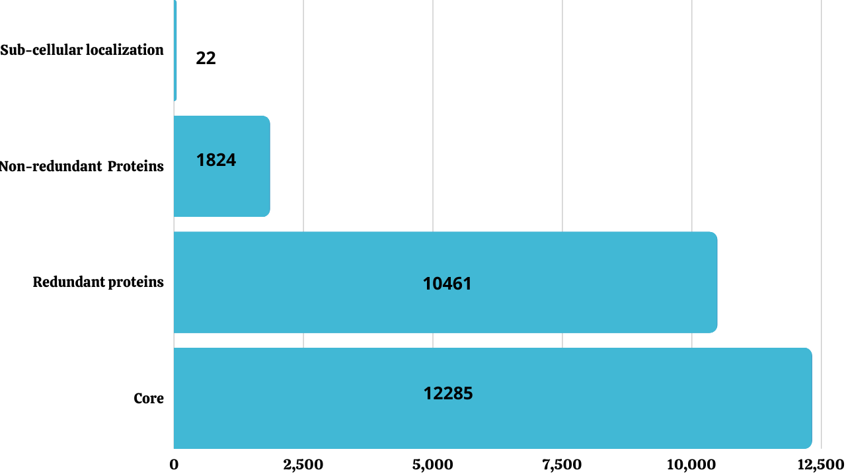
In this phase, we localize the proteins of the orthologous sequence of S. hominis. This is the most important step in selecting effective vaccine candidates. Proteins found in the inner and outer membranes, periplasmic spaces, and secretory proteins are promising candidates for vaccine construct development (Ahmad et al., 2019). These proteins play vital roles in the pathogenesis, invasion, and colonization of bacteria in host cells. Furthermore, the proteins are all surface proteins, and the antigenic epitopes of these proteins can efficiently be recognized by the host immune system and provoke innate immune responses (Pachathundikandi et al., 2013). Out of 1824 non-redundant sequences, only 22 extracellular protein sequences were opted for further processing. An online tool PSORTb, is used in the categorization of the protein localities. This tool is broadly used for determining the sub-cellular localization of proteins (Emanuelsson et al., 2007).

Figure 2. The overview of screening core proteins from different steps.

Virulence Check:
Virulence is the pathogen’s ability to cause infection in a host cell and initiate immune responses (Chisholm et al., 2006). The core redundant exoproteome/secretome were checked for virulence. This filtration of proteins was done through VFDB (Virulent Factor Database Analysis) with specific criteria of selection as mentioned in the methodology(Dalsass et al., 2019). A BLASTp search was performed to shortlist the proteins. Out of 22 non-redundant core sequences, only six (27.3%) proteins sequences were found virulent.
Table 3: List of virulent proteins.
Protein | VFDB
Extracellular | Bit Score | Sequence Identity
>core/1166/1/Org1_Gene1302 | 211 | 49%
>core/1180/1/Org1_Gene1448 | 169 | 45%
>core/1802/1/Org1_Gene1985 | 287 | 70%
>core/99/2/Org2_Gene1570 | 132 | 44%
>core/16/4/Org4_Gene1407 | 1569 | 58%

Transmembrane Helices and Physiochemical Properties Analysis:
Different physiochemical properties and transmembrane helices were evaluated to filter out the stable virulent proteins. The proteins with transmembrane helices 0 and 1 are selected. Such choices were made because of the failure of poor protein expression in in vitro system such as E. coli. Having more than two transmembrane helices makes it difficult to study and clone (Fan et al., 2011). In physiochemical properties, the prime factor to evaluate is the molecular weight.
Isolation and purification of proteins with low molecular weight are easy. The other factor to analyze is the instability index. The instability index computes the stability of proteins by analyzing the disulfide bonds in proteomic sequence. Out of six virulent proteins, three (50%) protein was screened out to be stable protein.

Table 4: Vaccine candidate prioritization
Physiochemical Properties and Transmembrane Helices
Extracellular Proteins | Transmembrane Helices | No of amino acids | Molecular Weight | Theoretical PI | Instability Index | Aliphatic Index
>core/1166/1/Org1_Gene1302 | 1 | 282 | 32287.61 | 8.37 | 17.03 | 76.49
>core/1180/1/Org1_Gene1448 | 0 | Doesn’t match the criteria  Discarded
>core/1679/1/Org1_Gene1002 | 0 | 200 | 22734.36 | 4.99 | 30.44 | 81.45
>core/1802/1/Org1_Gene1985 | 1 | 181 | 20818.54 | 9 | 20.19 | 74.75
>core/99/2/Org2_Gene1570 | 0 | Doesn’t match the criteria  Discarded
>core/16/4/Org4_Gene1407 | 0

Homology Check against Probiotics:
In NCBI, a BLASTp search was performed against probiotic lactobacillus bacteria species. These bacteria are commensals in the human gut and help to treat diarrhea, improve gut health, lipid metabolism, and modulate immune and inflammatory responses (Macfarlane et al., 2008). Any type of homology between the probiotic and pathogen proteomic sequence could interrupt the general gastrointestinal health and worsen the situation. In this filtration, only two proteins have no significant sequence similarity (Maiuolo et al., 2022).
Epitope selection:

B and T-Cells Epitope Prediction:
Specificity in killing pathogens is the foundation of adaptive immunity (Rivera et al., 2016). B and T cells are the fundamental units of adaptive immunity. These cells recognize and kill the pathogens by a series of chemical reactions and store the data in their memory cells to prevent the same infection in the future (Cohen et al., 2009). The process of memorizing the pathogen’s identity and immunological data becomes the fundamental principle of vaccination. The major cells involved in adaptive/acquired immunity are the T and B-lymphocytes (Sinha & Bhattacharya, 2006). They initiate two types of responses: humoral and cell-mediated immune response against specific pathogens. The filtered two proteins were used to predict B-sells epitopes, and then these epitopes were subsequently used for T-cell epitope mapping. B-cell epitope prediction is important because these epitopes could activate responses like agglutination, neutralization, opsonization, complement system, and cell mediated cytotoxicity administrated by antibody lymphocytes (natural killer cells, eosinophils, etc.) and can destruct the invader pathogen (Kapingidza et al., 2020). These epitopes were further used for T-cell epitope mapping, where important sites for MHC class I and II were predicted. The MHC I molecules are present on the surface of all nucleated body cells and present the pathogenic proteins to the cytotoxic T-cells. In the same way, MHC II molecules are expressed on the surface of special antigen-presenting cells like dendritic cells, monocytes, and B-lymphocytes (Purcell et al., 2007) . This displaying of the pathogenic proteins lead to the full-force production of antibodies (A. Khan et al., 2021).

B-Cell Epitopes | Peptides
>core/1166/1/Org1_Gene1302 | QIFFKKVNEVEKVQHVNVTLDKAAAKQIDNYTSQQVSNKNNNAW  RDASASEIKGAMDSSKFIDDDKQKYQFLDLSKY  QGIDKNRIKRMLFDRPTLLKHTD
 | KSELANGVNIDGKK
 | EDPIKTGAEYAKKHGWDT
 | SHDDQNTLYSMRWNPMNPGEH
 | KTEGKYFKLYVYKDDQ
>core/1802/1/Org1_Gene1985 | HTGPFKDDSQHSSSNSTQIELKGK
 | TVKPNTPVQPY
 | LAREKYFSPNGKYRST
Table 5: B-Cell epitopes

Table 6: T-Cell epitopes
T-Cell Epitopes
MHC II | Percentile Score | MHC I | Percentile Score
KNRIKRMLFDRPTLL | 0.21 | MLFDRPTLL | 0.01
 |  | KNRIKRMLF | 0.94
QKYQFLDLSKYQGID | 6.1 | YQFLDLSKY | 0.01
 |  | DLSKYQGID | 71
 |  | QKYQFLDLSK | 4.5
IKGAMDSSKFIDDDK | 6.2 | KGAMDSSKF | 1.1
 |  | SSKFIDDDK | 1.8
 |  | GAMDSSKFI | 1.5
NAWRDASASEIKGAM | 4.6 | SASEIKGAM | 0.23
 |  | NAWRDASAS | 4.9
QIDNYTSQQVSNKNN | 22 | YTSQQVSNK | 0.07
 |  | SQQVSNKNN | 17
 |  | QIDNYTSQQ | 2.8
VQHVNVTLDKAAAKQ | 3.2 | VTLDKAAAK | 0.02
 |  | VQHVNVTLDK | 1.8
 |  | VQHVNVTLDK | 2.2
QIFFKKVNEVEKVQH | 7.5 | IFFKKVNEV | 0.2
 |  | KVNEVEKVQH | 1.1
 |  | QIFFKKVNEV | 0.83
KSELANGVNID | 7.2 | SELANGVNI | 0.14
 |  | SELANGVNID | 4.9
 |  | KSELANGVNI | 1.1
SELANGVNIDGKK | 28 | SELANGVNI | 0.14
 |  | NGVNIDGKK | 3.2
DPIKTGAEYAKKH | 15 | DPIKTGAEY | 0.02
 |  | KTGAEYAKKH | 3.3
TGAEYAKKHGWDT | 31 | AEYAKKHGW | 0.01
 |  | YAKKHGWDT | 2.1
 |  | TGAEYAKKH | 4.4
NTLYSMRWNPMNPGE | 3.3 | SMRWNPMNP | 1.6
 |  | RWNPMNPGE | 3.2
 |  | NTLYSMRWNP | 11
SHDDQNTLYSMRWNP | 36 | DQNTLYSMR | 0.15
 |  | TLYSMRWNP | 3.5
 |  | SHDDQNTLY | 0.23
KTEGKYFKLYVYKDD | 3.5 | TEGKYFKLY | 0.01
 |  | YFKLYVYKDD | 48
TEGKYFKLYVYKDDQ | 4.3 | TEGKYFKLY | 0.01
 |  | KLYVYKDDQ | 15
DDSQHSSSNSTQIEL | 14 | HSSSNSTQI | 0.63
 |  | SSNSTQIEL | 0.76
 |  | DDSQHSSSNS | 32
QHSSSNSTQIELKGK | 18 | SSNSTQIELK | 0.06
 |  | STQIELKGK | 0.18
 |  | QHSSSNSTQI | 4.5
HTGPFKDDSQHSSSN | 19 | GPFKDDSQH | 0.84
 |  | DDSQHSSSN | 23
 |  | HTGPFKDDSQ | 13
TVKPNTPVQPY | 6 | KPNTPVQPY | 0.05
 |  | TVKPNTPVQ | 0.74
LAREKYFSPNGKYRS | 4.4 | KYFSPNGKY | 0.01
 |  | YFSPNGKYRS | 3.8
 |  | LAREKYFSP | 1.1
AREKYFSPNGKYRST | 4.5 | KYFSPNGKY | 0.01
 |  | SPNGKYRST | 0.2
 |  | AREKYFSPNG | 13

Epitope Prioritization:
Using different immunoinformatics approaches to prioritize the epitope selection. As a successful vaccine candidate, water-soluble, non-toxic, non-allergenic, and antigenic proteins were chosen (Aguttu et al., 2021). The antigenicity check measures the ability antigen to bind to antibodies and other lymphocytic products (Binz & Wigzell, 1975). The non-toxic, non-allergenic, water soluble and antigenic epitopes were listed in fig.
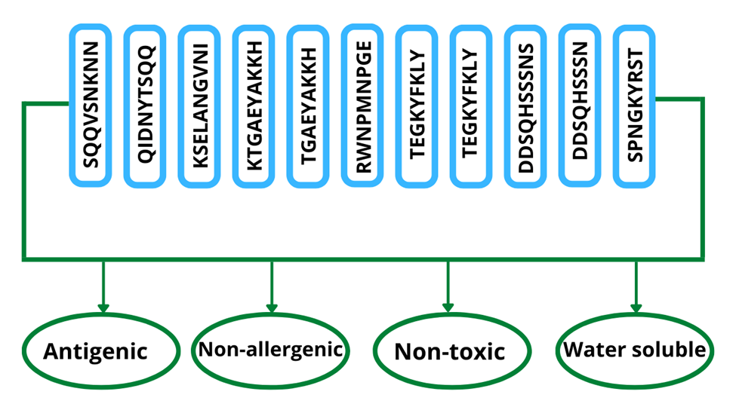
Figure 3. List of 11 shortlisted epitopes that are non-toxic, non-allergenic, antigenic and water-soluble

Vaccine construction:
As the MEV is the combination of many epitopes, these epitope domains were combined using GPGPG linkers (M. T. ul Qamar et al., 2021). Since protease enzymes can easily degrade the antigenic peptides and epitopes, the B-cell receptor (BCR) and T-cell receptor (TCR) can’t recognize them and thus have poor immunogenic effect (Zaman & Toth, 2013). In order to avoid this, the intramolecular adjuvants were used to boost the immune responses of MEV and efficient transmission inside the body (M. ul Qamar, Rehman, et al., 2020). This adjuvant molecule was linked with epitopes constructed with the help of the EAAK linker. The Cholera toxin b subunit adjuvant was used in the process(Aldakheel et al., 2021). The 3D structure of the construct modeled using 3D pro of protein scratch predictor. The structure is visualized using Chimera 1.16.

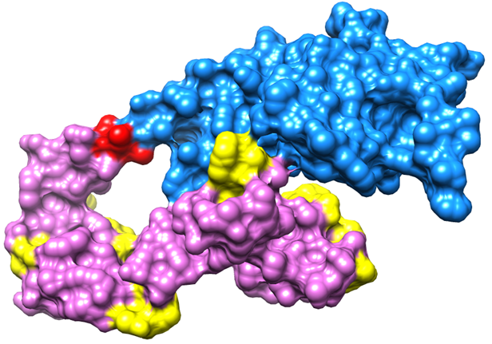

Figure 4. A visualized view of MEV construct Yellow color represent GPGPG linkers, blue color represent Cholera toxin B-subunit, red color (EAAAK linkers) and orchid color represent epitopes.

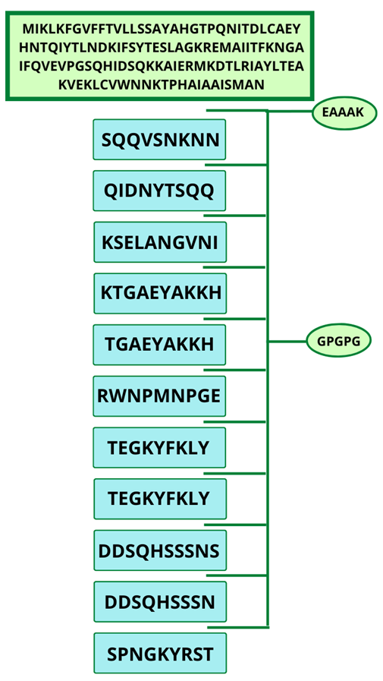
Figure 5. The schematic description of vaccine construct, Green represent Cholera Toxin B-subunit (adjuvant) link with epitopes through EAAK linkers and blue color represent epitopes link to each other with GPGPG linkers.

Multi Epitope Vaccine Construct Processing:

Molecular Docking:
Molecular docking analysis approaches were used to elucidate the interaction between the vaccine construct and host’s innate and adaptive immune cells (Safavi et al., 2020). To provoke immune response, the MEV should have good interaction with host’s immune cells receptors like TLR4, MHC-II and I. For this purpose, blind docking strategy was used to predict the interaction of MEV with host’s immune receptors (Al Saba et al., 2021). The results are tabulated in the table.
Table 7: PATCHDOCK results for MHC I.
Solution No | Score | Area | ACE | Transformation
1 | 19690 | 2856.90 | 243.71 | -0.03 0.30 -0.09 52.34 47.37 58.64
2 | 19200 | 3027.60 | 270.89 | 0.75 0.42 0.94 57.44 55.30 16.13
3 | 18192 | 3065.80 | 157.31 | -3.09 -0.32 -0.24 62.27 28.26 48.61
4 | 17630 | 3437.00 | 489.66 | 0.64 -0.12 -1.90 30.94 44.61 52.59
5 | 17448 | 2402.00 | 332.04 | -2.53 0.48 2.20 47.52 38.06 57.76
6 | 17354 | 2529.80 | 356.97 | -2.47 0.59 1.94 48.65 35.91 57.87
7 | 17298 | 2026.20 | 211.10 | -2.53 0.44 2.46 46.83 39.76 57.70
8 | 16830 | 2582.40 | 421.25 | -1.32 1.24 -0.69 16.14 44.00 37.89
9 | 16788 | 2898.30 | 123.86 | 2.57 -0.79 -1.91 7.67 22.75 27.87
10 | 16722 | 2468.90 | 80.82 | 0.36 -0.87 1.68 50.92 37.24 65.79
11 | 15864 | 2500.60 | 400.30 | 2.90 1.04 -1.53 39.11 -3.56 38.58
12 | 15804 | 2384.30 | 235.58 | -0.21 0.41 -0.16 48.41 47.33 59.09
13 | 15752 | 2633.60 | 211.87 | 1.34 -0.24 -3.02 25.94 15.16 18.01
14 | 15648 | 2207.40 | 349.69 | 2.57 -0.63 -2.05 5.24 25.83 31.22
15 | 15482 | 2210.30 | 339.58 | 0.90 0.63 2.53 10.72 23.61 32.81
16 | 15454 | 2190.40 | 430.68 | 1.85 -0.76 -2.43 47.55 26.12 8.92
17 | 15452 | 2184.50 | 448.16 | -0.33 -0.92 0.49 51.82 12.75 19.05
18 | 15436 | 2974.60 | 139.08 | 0.22 -0.06 -2.19 57.28 10.49 57.29
19 | 15404 | 3022.70 | 446.40 | -0.15 -0.29 0.67 13.83 38.25 47.47
20 | 15390 | 3328.10 | -35.46 | 2.70 -0.46 -1.70 46.00 55.26 63.86

Table 8: PATCHDOCK results for MHC II.
Solution No | Score | Area | ACE | Transformation
1 | 19030 | 2568.20 | 178.30 | -2.52 0.46 0.61 103.23 100.92 -12.98
2 | 19012 | 2616.00 | 174.36 | 3.12 -0.94 -3.01 118.54 31.94 -4.33
3 | 18762 | 3157.30 | 339.60 | -0.95 -1.48 -0.11 102.18 52.19 -15.79
4 | 17928 | 2860.90 | 498.89 | 2.13 -0.68 2.42 115.91 101.86 1.25
5 | 17924 | 3188.70 | -118.16 | -2.22 -0.86 -0.00 121.14 24.49 10.29
6 | 17584 | 2759.50 | -36.31 | 2.22 0.44 2.53 142.80 64.79 15.68
7 | 17258 | 2463.10 | 365.25 | 2.36 1.27 -2.48 85.84 67.41 3.01
8 | 16858 | 2782.20 | 189.39 | -1.26 -0.73 -0.94 146.96 58.95 -5.46
9 | 16806 | 2721.60 | 333.73 | 2.88 -0.76 -3.13 118.27 32.94 -6.90
10 | 16788 | 2957.30 | -44.01 | -3.09 -1.10 -3.03 117.35 34.09 -6.06
11 | 16616 | 2588.80 | 367.97 | -2.23 0.84 0.94 72.25 63.69 10.94
12 | 16606 | 2181.70 | 29.05 | 0.23 0.32 -2.44 94.64 88.42 -23.96
13 | 16602 | 2646.70 | 223.64 | 0.41 0.79 0.94 122.16 92.19 -6.03
14 | 16598 | 2646.80 | 289.18 | -1.62 0.07 0.15 72.26 77.33 -6.13
15 | 16542 | 2996.90 | 199.69 | -0.30 -0.95 -2.67 82.55 81.78 14.62
16 | 16534 | 2063.40 | 3.75 | 3.06 0.75 1.28 139.48 75.91 -15.37
17 | 16532 | 2808.00 | 17.66 | -1.36 -0.55 -0.95 149.27 54.23 -4.98
18 | 16338 | 3494.90 | 200.24 | 2.42 -1.51 -3.10 99.91 52.71 -12.04
19 | 16330 | 2461.90 | 116.63 | 0.88 0.49 2.74 89.56 69.78 -12.43
20 | 16262 | 2662.00 | 81.94 | 1.13 0.51 2.68 89.25 66.06 -9.25

Table 9: PATCHDOCK results for TLR4.
Solution No | Score | Area | ACE | Transformation
1 | 20864 | 2763.80 | 319.39 | -2.98 0.85 1.45 -48.02 20.31 -23.51
2 | 19780 | 2391.10 | 482.45 | -2.50 -0.35 2.08 -16.75 42.27 -16.53
3 | 19694 | 3221.60 | 338.75 | 0.84 -1.45 2.63 -0.69 18.65 -54.86
4 | 19676 | 2551.00 | 315.79 | -2.61 0.04 -1.92 9.24 32.35 -58.78
5 | 19228 | 2566.00 | 228.48 | -0.75 -0.01 -2.79 -33.15 41.12 -15.34
6 | 18084 | 3343.40 | 246.14 | 0.32 -1.46 2.08 1.33 18.82 -51.37
7 | 18058 | 4052.50 | 372.52 | 3.13 0.68 1.53 -43.62 21.45 -22.30
8 | 17838 | 2669.80 | 222.59 | -2.80 0.05 -1.83 -31.47 42.41 -10.22
9 | 17764 | 2476.80 | 177.68 | 3.11 0.80 1.69 -50.10 18.45 -24.37
10 | 17748 | 3277.60 | -178.96 | -1.03 -0.37 -1.37 17.61 33.74 -54.26
11 | 17652 | 2927.20 | 7.50 | 0.63 0.97 0.47 -55.98 24.76 -26.27
12 | 17566 | 3376.60 | 435.51 | -0.34 0.53 -1.72 -58.27 11.71 -52.97
13 | 17424 | 2759.50 | 95.73 | -0.28 -0.02 0.43 -15.69 49.62 -18.02
14 | 17340 | 3144.90 | 319.63 | -2.21 1.12 -2.60 -48.43 35.44 -21.42
15 | 17340 | 2747.30 | 93.26 | 2.49 0.83 -2.57 -57.86 24.72 -0.77
16 | 17322 | 2663.00 | 183.48 | -2.28 0.63 -0.33 -68.26 -18.01 4.10
17 | 17226 | 2159.20 | 218.29 | 0.42 -0.86 1.59 35.96 -6.27 -64.19
18 | 17218 | 2911.20 | 375.82 | -1.15 -0.50 -0.61 16.58 15.77 -70.72
19 | 17040 | 2249.90 | 421.54 | 0.38 -0.73 -1.75 -44.40 47.72 -11.97
20 | 17006 | 2235.50 | 218.89 | -2.60 0.40 1.70 -72.01 -1.85 5.10

Docking Refinement:
The PATCHDOCK results were further refined using FireDock. The top 10 docked complexes were subjected for refinement (Mashiach et al., 2008). FireDock refinement ranks the results with the lowest binding energy complex at the top and it goes down. The docked complexes having the lowest binding energy were selected (Andrusier et al., 2008), and then visualized using UCSF Chimera 1.16. For MHC-I, solution 8 was selected, for MHC-II, solution nine was selected and for TLR4 the solution 36 was selected. The results are shown in the table.
Table 10: FireDock results for MHC I
Rank | Solution Number | Global Energy | Attractive VdW | Repulsive VdW | ACE | HB
1 | 8 | -4.84 | -3.77 | 0.34 | -1.23 | -0.99
2 | 9 | 6.04 | -0.55 | 0.00 | 0.99 | 0.00
3 | 5 | 9.41 | -3.75 | 0.00 | 2.70 | -0.32
4 | 4 | 9.55 | -3.40 | 1.80 | 3.71 | -0.46
5 | 2 | 10.22 | -0.00 | 0.00 | -0.00 | 0.00
6 | 7 | 12.30 | -10.85 | 3.92 | 1.55 | 0.00
7 | 6 | 18.35 | -3.40 | 1.18 | 2.00 | 0.00
8 | 10 | 24.67 | -6.10 | 0.97 | 1.15 | 0.00
9 | 3 | 28.63 | -36.11 | 16.03 | 10.96 | -2.12
10 | 1 | 31.21 | -14.77 | 29.21 | 5.98 | -3.36

Table 11: FireDock results for MHCII
Rank | Solution Number | Global Energy | Attractive VdW | Repulsive VdW | ACE | HB
1 | 9 | 2.55 | -4.82 | 0.80 | 1.65 | 0.00
2 | 5 | 4.36 | -1.93 | 1.65 | -0.43 | 0.00
3 | 10 | 10.58 | -3.28 | 1.32 | 3.89 | -0.34
4 | 8 | 15.30 | -32.77 | 30.61 | 13.93 | -2.23
5 | 2 | 16.03 | -7.26 | 2.03 | 5.34 | -0.42
6 | 6 | 28.39 | -9.07 | 24.19 | 6.31 | -0.46
7 | 3 | 55.64 | -8.79 | 10.16 | 13.06 | 0.00
8 | 4 | 444.29 | -32.75 | 578.96 | 18.68 | -4.13
9 | 1 | 922.72 | -28.54 | 1153.02 | 19.35 | -4.68
10 | 7 | 1040.22 | -28.82 | 1310.23 | 15.62 | -5.01

Table 12: FireDock results for TLR4
Rank | Solution Number | Global Energy | Attractive VdW | Repulsive VdW | ACE | HB
1 | 8 | -36.67 | -32.83 | 33.92 | 2.84 | -6.88
2 | 1 | -3.76 | -25.41 | 6.33 | 10.26 | -2.29
3 | 4 | 2.59 | -1.90 | 0.30 | 0.62 | 0.00
4 | 2 | 20.09 | -49.11 | 52.92 | 16.08 | -7.74
5 | 5 | 364.56 | -27.61 | 498.29 | 1.45 | -2.59
6 | 9 | 511.26 | -63.30 | 728.16 | 0.06 | -3.96
7 | 3 | 776.89 | -38.99 | 1019.72 | 14.40 | -4.25
8 | 6 | 887.29 | -40.59 | 1162.81 | 10.78 | -2.95
9 | 7 | 1292.51 | -36.49 | 1632.36 | 20.70 | -1.52
10 | 10 | 7376.28 | -56.57 | 9336.35 | -11.09 | -6.70

Structure Visualization:
The refined docked structures were visualized using Chimera 1.16.
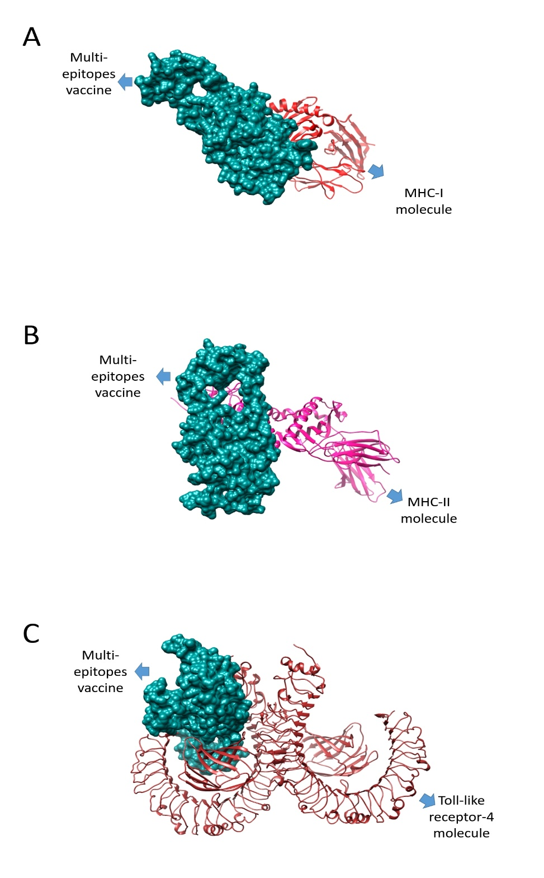
Figure 6. Top 3 modeled and visualized complexes of MHC I, MHC II and TLR4 respectively.

Codon optimization:
The codons are the complimentary nucleotide triplets of the genetic codes encoded in DNA(Clary & Wolstenholme, 1985). It decides which amino acid should be added to the growing protein chain in protein synthesis. There are a total of 64 codons for 20 different types of amino acids. Different organisms use different codons for the same amino acid (Bošnački et al., 2008). To get maximum expression in host cells, we need to optimize the codons accordingly. The protein sequence of MEV was reverse translated into DNA using a codon optimization technique. It optimizes the given sequence according to the host codon usage pattern. In this case, we selected E.coli (K12) as a host for our sequence expression (M. ul Qamar, Shahid, et al., 2020). The GC content of the sequence is 52% and the codon adaptation index is 0.95%. These values are considered ideal for the expression process. At last, the optimized MEV was cloned into the pET-28a (+) expression vector.

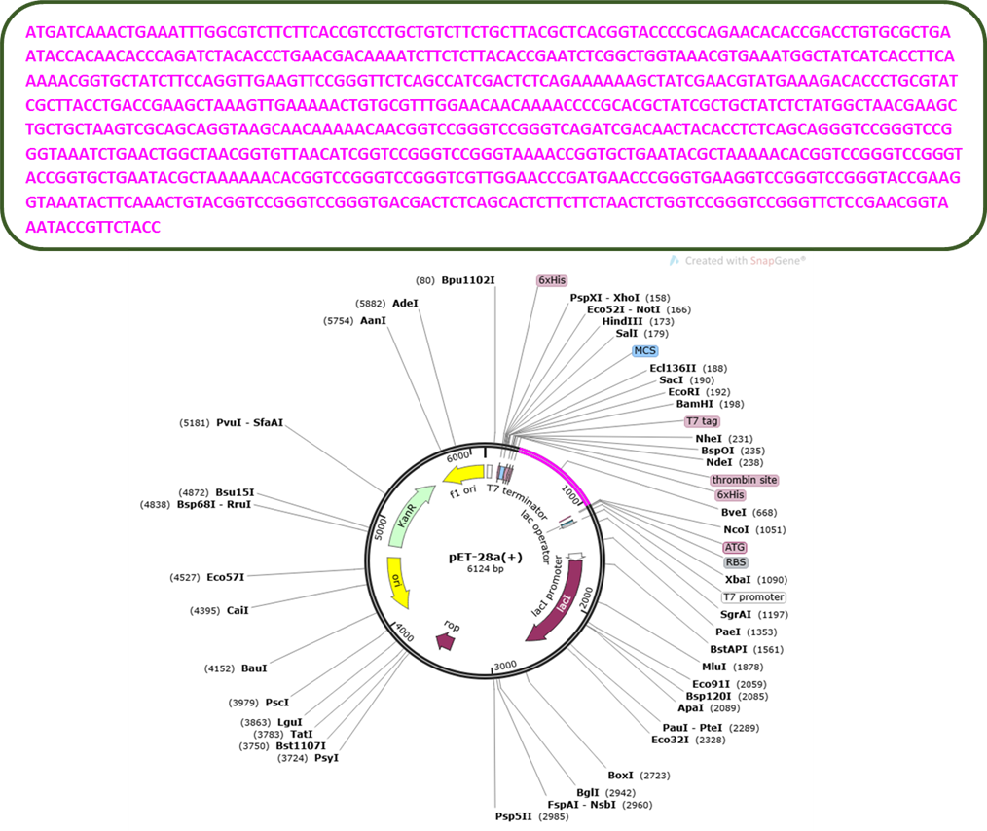

Figure 7. View of our MEV DNA sequence ligated into pET-28a(+) vector

Improving structure stability:

Disulfide Engineering:
In protein engineering improving the stability of proteins is one of the main goal. The best logical approach is to improve the stabilizing molecular interactions found naturally in proteins (Dombkowski et al., 2014). Disulfide bridges are covalent bonds that provide considerable structural stability. Disulfide engineering is a method of directing disulfide bonds into the vaccine construct to make it structurally stable. Many residues are enzyme degradable, so they were replaced with cysteine residues in the vaccine construct (Gongora-Benitez et al., 2014). The mutant and original structures are shown in the figure.
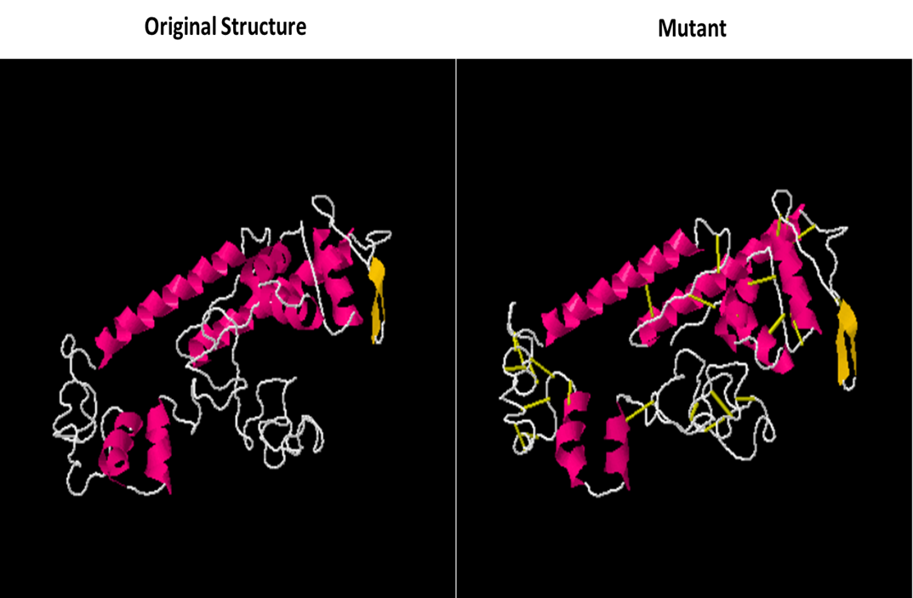
Figure 8. Original and mutant structure of the MEV construct. The yellowish highlighted area in the mutant shown introduction of disulfide bonds into the structure.

Loop Modeling:
A good vaccine candidate has a stable, relaxed structure which is an important characteristic. It is achieved through loop modelling for the residues given in the table.
Table 13: Loop modelling for the residues.
Pair of residues | Chi3 | Energy
LEU4-GLU104 | 116.71 | 3.66
PHE10-ASN25 | -88.2 | 5.92
LEU13-ASP28 | 109.19 | 3.15
LEU13-ASN35 | 80.16 | 3.35
THR27-TYR33 | 92.9 | 4.18
THR36-LEU41 | 95.75 | 3.06
ILE38-LEU41 | 114.86 | 3.82
THR49-ALA53 | -99.93 | 4.39
GLU50-HIS78 | -99.21 | 2.56
MET58-ALA67 | -88.37 | 3.6
PRO74-GLN77 | -103.37 | 2.03
ALA96-LYS102 | -80.09 | 2.7
ALA96-ALA119 | -106.52 | 1.15
LEU106-TRP109 | 93.83 | 3.1
TRP109-LYS112 | 79.05 | 0.99
PRO140-THR149 | -84.69 | 5.82
GLY143-ASP146 | -78.71 | 2.98
ASN147-SER150 | 78.25 | 2.72
TYR148-PRO169 | -99.43 | 5.6
SER150-GLY153 | 99.22 | 0.78
PRO154-GLY168 | -91.74 | 0.15
GLY157-GLU160 | 80.42 | 4.03
ALA162-VAL165 | -62.14 | 6.82
GLY170-LYS173 | -106.59 | 3.22
GLY175-ALA179 | 120.42 | 9.13
TYR192-GLY199 | 90.13 | 5.39
PHE221-TYR224 | 101.86 | 2.6
LYS222-GLN233 | -85.19 | 2.76
GLY225-SER245 | 67.24 | 5.62
GLY227-ASP230 | -95.1 | 2.68
ASP231-PRO243 | -77.12 | 3.04

Molecular dynamic simulation:
MD simulation is a method for understanding molecular behavior and properties at the atomic level. It provides useful information about the structure, interaction energies, and movement of atoms (dynamics) that complements the experimental data(Klajmon & Cervinka, 2021), (Ando & Amato, 2009). In this process, the interaction of two molecules is evaluated at different conditions of temperature and pressure for a short time period by using different algorithms and ensembles. The RMSD value was calculated based on the alpha carbon atom. The top 3 complexes were analyzed. The graph shows a steady line although the vaccine and TLR4 complex show some deviation the line fluctuates (Salomon-Ferrer et al., 2013) around the value 12-14Å.
The maim goal here is to investigate the vaccine binding interaction with host immune cells and initiate immune responses.
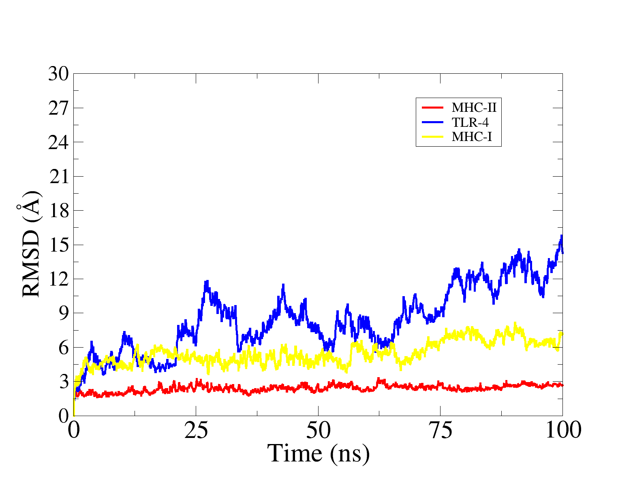

Figure 9. RMSD plot of our multi epitope vaccine construct.

Binding Free Energies calculations:
Binding free energies of the top 3 docked complexes were calculated using MM-GBSA approach (Zhang et al., 2017). The total binding free energies of TLR4, MHC I and MHC II complex is -74.47 kcal/mol, -62.25 kcal/mol and -71.95 kcal/mol respectively.
Table 14: Binding free energies calculations.
Energy Parameter | TLR-4-Vaccine Complex | MHC-I-Vaccine Complex | MHC-II-Vaccine Complex
MM-GBSA
VDWAALS | -56.68 | -51.38 | -66.62
EEL | -33.65 | -32.55 | -25.87
Delta G gas | -90.33 | -83.93 | -92.49
Delta G solv | 15.86 | 21.68 | 20.54
Delta Total | -74.47 | -62.25 | -71.95

VDWAALS (van der Waals), EEL (electrostatic), Delta G gas (net gas phase energy), Delta G solv (net solvation energy), Delta Total (net energy of system).

Discussion
The current study is an in silico based model of a multi-epitope vaccine against S. hominis. We used a computational framework to evaluate the core proteomes of S. hominis for non-homologous, antigenic, and highly conserved proteome among all the strains of S. hominis. These proteins were further used to screen antigenic, non-allergenic, non-toxic, and water-soluble epitopes for B and T cell alleles. Further analysis (such as analyzing docking, MD simulation, and biding energies calculations results) reveals great immunogenic effects and stable molecular configurations (Chinnasamy et al., 2020).
In recent history, an exponential growth of antimicrobial resistance has been observed because of the overuse of antibiotics often deviated from its prescription. Once the strain emerges with antibiotic resistance, it can spread quickly and acquire resistance to other classes of drugs as well. These multi-drug resistant bacteria limit the choice of choosing specific antibiotics. It increases the mortality and morbidity rate. It is estimated that by 2050, 10 million lives a year may be lost to AMR, exceeding the 8.2 million lives a year currently lost to can¬cer5. To put this number in perspective at least 700,000 people die of resistant infections every year globally, more than the combined number of deaths caused by tetanus, cholera, and measles (Gautham et al., 2021). It is a big loss to the economy as well. It has been estimated that, if the AMR trend continues, the cumulative loss to world economies might be as high as $100 trillion by 2050 (Jasovsk\`y et al., 2016).
The development of new drugs cannot keep pace with the increasing risk of antimicrobial resistant. However, immunization of individuals through vaccination can affect this directly and indirectly (Micoli et al., 2021). As the development of vaccine greatly reduced the intake of antibiotics which in turn decreased the chances of emerging new antimicrobial resistant strains. Traditional vaccinology approaches had several defects i.e. they generates inaccurate immune responses, lengthy processing time, high cost, less specificity, less safety, hypersensitivity, and less stability (Jiang et al., 2005). Computational vaccine designing strategies are growing exponentially, mainly because of the huge growth of genomic data and allowed scientists to move beyond pasture’s rule of vaccinology and use computational approaches, tools, and software to design vaccines without the need for any wet lab techniques.
Previous study conducted by Aldakheel F, Abrab A, Munir S 2021 on designing a MEV using proteome-wide mapping and reverse vaccinology used the same computational framework to model highly antigenic and potent MEV targets against Clostridium perfringens (Aldakheel et al., 2021). The same computational was used by R Attar, E. Alatawi, F. Aba Alkhayl 2022. They design a novel MEV against Staphylococcus auricularis using immunoinformatics and biophysics approaches. They prioritize the vaccine candidate on tight criteria given in the literature. The vaccine candidate is non-homologic, conserved and immunogenic. The epitopes derived from these proteins were also immunogenic, non-allergic, non-toxic, and water-soluble. These epitopes are derived for B and T cell alleles. This MEV construct has higher molecular stability and an efficient immune response, according to simulation and binding energies calculations. (Aldakheel et al., 2021).

Conclusion and Recommendations:
Our work presents an in-silico design of a broad-spectrum multi-epitope vaccine against S. hominis. the vaccine construct is composed of antigenic, non-allergic, non-toxic multi epitopes extracted from highly virulent proteins that are part of pathogen’s core exoproteome (Shahid et al., 2021). Many immunoinformatics, biophysical, and subtractive proteomic techniques were used in the process (Allemailem, 2021). In selecting the vaccine candidate for vaccine development, tough selection criteria are used, such as these proteins should be from the core proteome, present on cell surface or are excretory in nature, non-homologous to the host and probiotics (Satyam et al., 2020). The epitopes that are prioritized are non-allergenic, non-toxic, antigenic, water-soluble, and had higher binding affinity to B and T cell alleles. The results of MD simulation and binding energies calculations elaborates the stable molecular configuration and minimize system energies. Although the pan genome based reverse vaccinology is an effective method to develop multi epitope vaccine but the potency of vaccine should be studied and confirmed by in vivo and in vitro immunological methods (Dar et al., 2021).

References
Abbas, G., Zafar, I., Ahmad, S., & Azam, S. S. (2020). Staphylococcus hominis native mitral valve bacterial endocarditis (SBE) in a patient with hypertrophic obstructive cardiomyopathy. Heart \& Lung, 36(5), 380–382.l multi-e. European Journal of Pharmaceutical Sciences, 142. https://doi.org/10.1016/j.ejps.2019.105160
Abdalla, N. M., Haimour, W. O., Osman, A. A., Sarhan, M. A., & Musaa, H. A. (2013). Antibiotics sensitivity profile towards Staphylococcus hominis in Assir region of Saudi Arabia. Journal of Scientific Research, 5(1), 171–183.
Aguttu, C., Okech, B. A., Mukisa, A., & Lubega, G. W. (2021). Screening and characterization of hypothetical proteins of Plasmodium falciparum as novel vaccine candidates in the fight against malaria using reverse vaccinology. Journal of Genetic Engineering and Biotechnology, 19(1), 1–13.
Ahmad, S., Ranaghan, K. E., & Azam, S. S. (2019). Combating tigecycline resistant Acinetobacter baumannii: A leap forward towards multi-epitope based vaccine discovery. European Journal of Pharmaceutical Sciences, 132, 1–17.
Ahmed, N. H., Baruah, F. K., & Grover, R. K. (2017). Staphylococcus hominis subsp. novobiosepticus, an emerging multidrug-resistant bacterium, as a causative agent of septicaemia in cancer patients. The Indian Journal of Medical Research, 146(3), 420.
Al-Megrin, W. A. I., Karkashan, A., Alnuqaydan, A. M., Aba Alkhayl, F. F., Alrumaihi, F., Almatroudi, A., & Allemailem, K. S. (2022). Design of a Multi-Epitopes Based Chimeric Vaccine against Enterobacter cloacae Using Pan-Genome and Reverse Vaccinology Approaches. Vaccines, 10(6), 886.
Al Saba, A., Adiba, M., Saha, P., Hosen, M. I., Chakraborty, S., & Nabi, A. H. M. N. (2021). An in-depth in silico and immunoinformatics approach for designing a potential multi-epitope construct for the effective development of vaccine to combat against SARS-CoV-2 encompassing variants of concern and interest. Computers in Biology and Medicine, 136, 104703.
Alberts, B., Johnson, A., Lewis, J., Raff, M., Roberts, K., & Walter, P. (2002). Membrane proteins. In Molecular Biology of the Cell. 4th edition. Garland Science.
Aldakheel, F. M., Abrar, A., Munir, S., Aslam, S., Allemailem, K. S., Khurshid, M., & Ashfaq, U. A. (2021). Proteome-Wide Mapping and Reverse Vaccinology Approaches to Design a Multi-Epitope Vaccine against Clostridium perfringens. Vaccines, 9(10), 1079.
Alharbi, M., Alshammari, A., Alasmari, A. F., Alharbi, S. M., ul Qamar, M., Ullah, A., Ahmad, S., Irfan, M., & Khalil, A. A. K. (2022). Designing of a Recombinant Multi-Epitopes Based Vaccine against Enterococcus mundtii Using Bioinformatics and Immunoinformatics Approaches. International Journal of Environmental Research and Public Health, 19(6), 3729.
Allemailem, K. S. (2021). A Comprehensive Computer Aided Vaccine Design Approach to Propose a Multi-Epitopes Subunit Vaccine against Genus Klebsiella Using Pan-Genomics, Reverse Vaccinology, and Biophysical Techniques. Vaccines, 9(10), 1087.
Ando, T., & Amato, I. Y. (2009). Basics of Molecular Simulation and its Application to Biomolecules. Quantum Bio-Informatics II: From Quantum Information to Bio-Informatics, Md, 228–241. https://doi.org/10.1142/9789814273756_0021
Andrusier, N., Mashiach, E., Nussinov, R., & Wolfson, H. J. (2008). Principles of flexible protein--protein docking. Proteins: Structure, Function, and Bioinformatics, 73(2), 271–289.
Arumugam, S., & Varamballi, P. (2021). In-silico design of envelope based multi-epitope vaccine candidate against Kyasanur forest disease virus. Scientific Reports, 11(1), 17118.
Asad, Y., Ahmad, S., Rungrotmongkol, T., Ranaghan, K. E., & Azam, S. S. (2018). Immuno-informatics driven proteome-wide investigation revealed novel peptide-based vaccine targets against emerging multiple drug resistant Providencia stuartii. Journal of Molecular Graphics and Modelling, 80, 238–250.
BAWA, C., Dixit, P., Preeti, P., & others. (2022). Evaluation Of DnaJ Chaperone as a Potential Vaccine Candidate Using Computational Tools.
Binz, H., & Wigzell, H. (1975). Shared idiotypic determinants on B and T lymphocytes reactive against the same antigenic determinants. I. Demonstration of similar or identical idiotypes on IgG molecules and T-cell receptors with specificity for the same alloantigens. The Journal of Experimental Medicine, 142(1), 197–211.
Boers, S. A., Jansen, R., & Hays, J. P. (2019). Understanding and overcoming the pitfalls and biases of next-generation sequencing (NGS) methods for use in the routine clinical microbiological diagnostic laboratory. European Journal of Clinical Microbiology \& Infectious Diseases, 38(6), 1059–1070.
Bordbar, A., Bagheri, K. P., Ebrahimi, S., & Parvizi, P. (2020). Bioinformatics analyses of immunogenic T-cell epitopes of LeIF and PpSP15 proteins from Leishmania major and sand fly saliva used as model antigens for the design of a multi-epitope vaccine to control leishmaniasis. Infection, Genetics and Evolution, 80, 104189.
Bošnački, D., ten Eikelder, H. M. M., Steijaert, M. N., & de Vink, E. P. (2008). Stochastic analysis of amino acid substitution in protein synthesis. International Conference on Computational Methods in Systems Biology, 367–386.
Carruthers, M., Yurchenko, A. A., Augley, J. J., Adams, C. E., Herzyk, P., & Elmer, K. R. (2018). De novo transcriptome assembly, annotation and comparison of four ecological and evolutionary model salmonid fish species. BMC Genomics, 19(1), 1–17.
Case, D. A., Aktulga, H. M., Belfon, K., Ben-Shalom, I., Brozell, S. R., Cerutti, D. S., Cheatham III, T. E., Cruzeiro, V. W. D., Darden, T. A., Duke, R. E., & others. (2021). Amber 2021. University of California, San Francisco.
Chaudhari, N. M., Gupta, V. K., & Dutta, C. (2016). BPGA-an ultra-fast pan-genome analysis pipeline. Scientific Reports, 6. https://doi.org/10.1038/srep24373
Chauhan, V., Rungta, T., Goyal, K., & Singh, M. P. (2019). Designing a multi-epitope based vaccine to combat Kaposi Sarcoma utilizing immunoinformatics approach. Scientific Reports, 9(1), 1–15.
Chinnasamy, S., Selvaraj, G., Selvaraj, C., Kaushik, A. C., Kaliamurthi, S., Khan, A., Singh, S. K., & Wei, D.-Q. (2020). Combining in silico and in vitro approaches to identification of potent inhibitor against phospholipase A2 (PLA2). International Journal of Biological Macromolecules, 144, 53–66.
Chisholm, S. T., Coaker, G., Day, B., & Staskawicz, B. J. (2006). Host-microbe interactions: shaping the evolution of the plant immune response. Cell, 124(4), 803–814.
Clary, D. O., & Wolstenholme, D. R. (1985). The mitochondrial DNA molecule ofDrosophila yakuba: nucleotide sequence, gene organization, and genetic code. Journal of Molecular Evolution, 22(3), 252–271.
Cohen, N. R., Garg, S., & Brenner, M. B. (2009). Antigen presentation by CD1: lipids, T cells, and NKT cells in microbial immunity. Advances in Immunology, 102, 1–94.
Dalsass, M., Brozzi, A., Medini, D., & Rappuoli, R. (2019). Comparison of open-source reverse vaccinology programs for bacterial vaccine antigen discovery. Frontiers in Immunology, 10, 113.
Dar, H. A., Ismail, S., Waheed, Y., Ahmad, S., Jamil, Z., Aziz, H., Hetta, H. F., & Muhammad, K. (2021). Designing a multi-epitope vaccine against Mycobacteroides abscessus by pangenome-reverse vaccinology. Scientific Reports, 11(1), 1–18.
Das, N. C., Patra, R., Gupta, P. S. Sen, Ghosh, P., Bhattacharya, M., Rana, M. K., & Mukherjee, S. (2021). Designing of a novel multi-epitope peptide based vaccine against Brugia malayi: An in silico approach. Infection, Genetics and Evolution, 87, 104633.
Dash, R., Das, R., Junaid, M., Akash, M. F. C., Islam, A., & Hosen, S. M. Z. (2017). In silico-based vaccine design against Ebola virus glycoprotein. Advances and Applications in Bioinformatics and Chemistry, 11–28.
Deng, H., Yu, S., Guo, Y., Gu, L., Wang, G., Ren, Z., Li, Y., Li, K., & Li, R. (2020). Development of a multivalent enterovirus subunit vaccine based on immunoinformatic design principles for the prevention of HFMD. Vaccine, 38(20), 3671–3681.
Dhanda, S. K., Mahajan, S., Paul, S., Yan, Z., Kim, H., Jespersen, M. C., Jurtz, V., Andreatta, M., Greenbaum, J. A., Marcatili, P., & others. (2019). IEDB-AR: immune epitope database—analysis resource in 2019. Nucleic Acids Research, 47(W1), W502--W506.
Dombkowski, A. A., Sultana, K. Z., & Craig, D. B. (2014). Protein disulfide engineering. FEBS Letters, 588(2), 206–212.
Donati, C., & Rappuoli, R. (2013). Reverse vaccinology in the 21st century: improvements over the original design. Annals of the New York Academy of Sciences, 1285(1), 115–132.
Emanuelsson, O., Brunak, S., Von Heijne, G., & Nielsen, H. (2007). Locating proteins in the cell using TargetP, SignalP and related tools. Nature Protocols, 2(4), 953–971.
Faiza, M., Abdullah, T., Calderon-Tantalean, J. F., Upadhyay, M. R., Abdelmoneim, A. H., Akram, F., Thakur, B. S., Abdulaziz, I., Ononamadu, C. J., Ghoraba, D. A., & others. (2020). In silico multi-epitope vaccine against covid19 showing effective interaction with HLA-B* 15: 03. BioRxiv, 2006–2020.
Fan, J., Heng, J., Dai, S., Shaw, N., Zhou, B., Huang, B., He, Z., Wang, Y., Jiang, T., Li, X., & others. (2011). An efficient strategy for high throughput screening of recombinant integral membrane protein expression and stability. Protein Expression and Purification, 78(1), 6–13.
Freschi, L., Vincent, A. T., Jeukens, J., Emond-Rheault, J.-G., Kukavica-Ibrulj, I., Dupont, M.-J., Charette, S. J., Boyle, B., & Levesque, R. C. (2019). The Pseudomonas aeruginosa pan-genome provides new insights on its population structure, horizontal gene transfer, and pathogenicity. Genome Biology and Evolution, 11(1), 109–120.
Gautham, M., Spicer, N., Chatterjee, S., & Goodman, C. (2021). What are the challenges for antibiotic stewardship at the community level? An analysis of the drivers of antibiotic provision by informal healthcare providers in rural India. Social Science \& Medicine, 275, 113813.
Ghosh, P., Bhakta, S., Bhattacharya, M., Sharma, A. R., Sharma, G., Lee, S.-S., & Chakraborty, C. (2021). A novel multi-epitopic peptide vaccine candidate against Helicobacter pylori: in-silico identification, design, cloning and validation through molecular dynamics. International Journal of Peptide Research and Therapeutics, 27(2), 1149–1166.
Gongora-Benitez, M., Tulla-Puche, J., & Albericio, F. (2014). Multifaceted roles of disulfide bonds. Peptides as therapeutics. Chemical Reviews, 114(2), 901–926.
Guest, J. D., Vreven, T., Zhou, J., Moal, I., Jeliazkov, J. R., Gray, J. J., Weng, Z., & Pierce, B. G. (2021). An expanded benchmark for antibody-antigen docking and affinity prediction reveals insights into antibody recognition determinants. Structure, 29(6), 606–621.
Gul, S., Ahmad, S., Ullah, A., Ismail, S., Khurram, M., ul Qamar, M., Hakami, A. R., Alkhathami, A. G., Alrumaihi, F., & Allemailem, K. S. (2022). Designing a recombinant vaccine against Providencia rettgeri using immunoinformatics approach. Vaccines, 10(2), 189.
Hajighahramani, N., Nezafat, N., Eslami, M., Negahdaripour, M., Rahmatabadi, S. S., & Ghasemi, Y. (2017). Immunoinformatics analysis and in silico designing of a novel multi-epitope peptide vaccine against Staphylococcus aureus. Infection, Genetics and Evolution, 48, 83–94.
Hanssen, A.-M., & Sollid, J. U. E. (2007). Multiple staphylococcal cassette chromosomes and allelic variants of cassette chromosome recombinases in Staphylococcus aureus and coagulase-negative staphylococci from Norway. Antimicrobial Agents and Chemotherapy, 51(5), 1671–1677.
Hengphasatporn, K., Kungwan, N., & Rungrotmongkol, T. (2019). Binding pattern and susceptibility of epigallocatechin gallate against envelope protein homodimer of Zika virus: A molecular dynamics study. Journal of Molecular Liquids, 274, 140–147.
Hu, G., & Kurgan, L. (2019). Sequence similarity searching. Current Protocols in Protein Science, 95(1), e71.
Ismail, S., Ahmad, S., & Azam, S. S. (2020). Protein localized at the inner and outer membrane, periplasmic spaces and secretory proteins were selected for the next phase. The protein with multiple and unknown localization were discarded. European Journal of Pharmaceutical Sciences, 146. https://doi.org/10.1016/j.ejps.2020.105258
Ismail, S., Shahid, F., Khan, A., Bhatti, S., Ahmad, S., Naz, A., Almatroudi, A., & ul Qamar, M. T. (2021). Pan-vaccinomics approach towards a universal vaccine candidate against WHO priority pathogens to address growing global antibiotic resistance. Computers in Biology and Medicine, 136, 104705.
Jalal, K., Abu-Izneid, T., Khan, K., Abbas, M., Hayat, A., Bawazeer, S., & Uddin, R. (2022). Identification of vaccine and drug targets in Shigella dysenteriae sd197 using reverse vaccinology approach. Scientific Reports, 12(1), 1–19.
Jasovsk\`y, D., Littmann, J., Zorzet, A., & Cars, O. (2016). Antimicrobial resistance—a threat to the world’s sustainable development. Upsala Journal of Medical Sciences, 121(3), 159–164.
Jiang, W., Gupta, R. K., Deshpande, M. C., & Schwendeman, S. P. (2005). Biodegradable poly (lactic-co-glycolic acid) microparticles for injectable delivery of vaccine antigens. Advanced Drug Delivery Reviews, 57(3), 391–410.
Jones, B. J., Kan, C. N. E., Luo, C., & Kazlauskas, R. J. (2020). Consensus Finder web tool to predict stabilizing substitutions in proteins. Methods in Enzymology, 643, 129–148.
Jonkheer, E. M., Brankovics, B., Houwers, I. M., van der Wolf, J. M., Bonants, P. J. M., Vreeburg, R. A. M., Bollema, R., de Haan, J. R., Berke, L., Smit, S., & others. (2021). The Pectobacterium pangenome, with a focus on Pectobacterium brasiliense, shows a robust core and extensive exchange of genes from a shared gene pool. BMC Genomics, 22(1), 1–18.
Kapingidza, A. B., Kowal, K., & Chruszcz, M. (2020). Antigen--antibody complexes. Vertebrate and Invertebrate Respiratory Proteins, Lipoproteins and Other Body Fluid Proteins, 465–497.
Kar, T., Narsaria, U., Basak, S., Deb, D., Castiglione, F., Mueller, D. M., & Srivastava, A. P. (2020). A candidate multi-epitope vaccine against SARS-CoV-2. Scientific Reports, 10(1), 1–24.
Khan, A., Khan, S., Saleem, S., Nizam-Uddin, N., Mohammad, A., Khan, T., Ahmad, S., Arshad, M., Ali, S. S., Suleman, M., & others. (2021). Immunogenomics guided design of immunomodulatory multi-epitope subunit vaccine against the SARS-CoV-2 new variants, and its validation through in silico cloning and immune simulation. Computers in Biology and Medicine, 133, 104420.
Khan, Z., Sanjai, S., Harshitha, B. V, Patil, S., & others. (2023). In-silico multi-epitope vaccine candidate against type-1 parainfluenza virus.
Klajmon, M., & Cervinka, C. (2021). Does explicit polarizability improve simulations of phase behavior of ionic liquids? Journal of Chemical Theory and Computation, 17(10), 6225–6239.
Kumar, A., Kumar, P., Saumya, K. U., Kapuganti, S. K., Bhardwaj, T., & Giri, R. (2020). Exploring the SARS-CoV-2 structural proteins for multi-epitope vaccine development: an in-silico approach. Expert Review of Vaccines, 19(9), 887–898.
Lim, H. X., Lim, J., Jazayeri, S. D., Poppema, S., & Poh, C. L. (2021). Development of multi-epitope peptide-based vaccines against SARS-CoV-2. Biomedical Journal, 44(1), 18–30.
Macfarlane, G. T., Steed, H., & Macfarlane, Sjj. (2008). Bacterial metabolism and health-related effects of galacto-oligosaccharides and other prebiotics. Journal of Applied Microbiology, 104(2), 305–344.
Mahmud, S., Rafi, M., Paul, G. K., Promi, M. M., Shimu, M., Sultana, S., Biswas, S., Emran, T. Bin, Dhama, K., Alyami, S. A., & others. (2021). Designing a multi-epitope vaccine candidate to combat MERS-CoV by employing an immunoinformatics approach. Scientific Reports, 11(1), 1–20.
Maiuolo, J., Musolino, V., Gliozzi, M., Carresi, C., Scarano, F., Nucera, S., Scicchitano, M., Oppedisano, F., Bosco, F., Macri, R., & others. (2022). Involvement of the Intestinal Microbiota in the Appearance of Multiple Sclerosis: Aloe vera and Citrus bergamia as Potential Candidates for Intestinal Health. Nutrients, 14(13), 2711.
Mashiach, E., Schneidman-Duhovny, D., Andrusier, N., Nussinov, R., & Wolfson, H. J. (2008). FireDock: a web server for fast interaction refinement in molecular docking. Nucleic Acids Research, 36(suppl\_2), W229--W232.
Masignani, V., Pizza, M., & Moxon, E. R. (2019). The development of a vaccine against meningococcus B using reverse vaccinology. Frontiers in Immunology, 10, 751.
McCarthy, C. G. P., & Fitzpatrick, D. A. (2019). Pan-genome analyses of model fungal species. Microbial Genomics, 5(2).
Mendoza-Olazarán, S., Morfin-Otero, R., Rodr\’\iguez-Noriega, E., Llaca-D\’\iaz, J., Flores-Treviño, S., González-González, G. M., Villarreal-Treviño, L., & Garza-González, E. (2013). Microbiological and molecular characterization of Staphylococcus hominis isolates from blood. PLoS One, 8(4), e61161.
Meza, B., Ascencio, F., Sierra-Beltrán, A. P., Torres, J., & Angulo, C. (2017). A novel design of a multi-antigenic, multistage and multi-epitope vaccine against Helicobacter pylori: an in silico approach. Infection, Genetics and Evolution, 49, 309–317.
Micoli, F., Bagnoli, F., Rappuoli, R., & Serruto, D. (2021). The role of vaccines in combatting antimicrobial resistance. In Nature Reviews Microbiology (Vol. 19, Issue 5, pp. 287–302). Nature Research. https://doi.org/10.1038/s41579-020-00506-3
Naveed, M., Yaseen, A. R., Khalid, H., Ali, U., Rabaan, A. A., Garout, M., Halwani, M. A., Al Mutair, A., Alhumaid, S., Al Alawi, Z., & others. (2022). Execution and Design of an Anti HPIV-1 Vaccine with Multiple Epitopes Triggering Innate and Adaptive Immune Responses: An Immunoinformatic Approach. Vaccines, 10(6), 869.
Pachathundikandi, S. K., Tegtmeyer, N., & Backert, S. (2013). Signal transduction of Helicobacter pylori during interaction with host cell protein receptors of epithelial and immune cells. Gut Microbes, 4(6), 454–474.
Purcell, A. W., McCluskey, J., & Rossjohn, J. (2007). More than one reason to rethink the use of peptides in vaccine design. Nature Reviews Drug Discovery, 6(5), 404–414.
Rahman, S., Sarkar, K., & Das, A. K. (2023). Exploring staphylococcal superantigens to design a potential multi-epitope vaccine against Staphylococcus aureus: an in-silico reverse vaccinology approach. Journal of Biomolecular Structure and Dynamics, 1–15.
Rai, N., Tiwari, S. P., & Maginn, E. J. (2012). Force field development for actinyl ions via quantum mechanical calculations: an approach to account for many body solvation effects. The Journal of Physical Chemistry B, 116(35), 10885–10897.
Ras-Carmona, A., Pelaez-Prestel, H. F., Lafuente, E. M., & Reche, P. A. (2021). BCEPS: a web server to predict linear B cell epitopes with enhanced immunogenicity and cross-reactivity. Cells, 10(10), 2744.
Rivera, A., Siracusa, M. C., Yap, G. S., & Gause, W. C. (2016). Innate cell communication kick-starts pathogen-specific immunity. Nature Immunology, 17(4), 356–363.
Safavi, A., Kefayat, A., Mahdevar, E., Abiri, A., & Ghahremani, F. (2020). Exploring the out of sight antigens of SARS-CoV-2 to design a candidate multi-epitope vaccine by utilizing immunoinformatics approaches. Vaccine, 38(48), 7612–7628.
Salomon-Ferrer, R., Gotz, A. W., Poole, D., Le Grand, S., & Walker, R. C. (2013). Routine microsecond molecular dynamics simulations with AMBER on GPUs. 2. Explicit solvent particle mesh Ewald. Journal of Chemical Theory and Computation, 9(9), 3878–3888.
Sanami, S., Rafieian-Kopaei, M., Dehkordi, K. A., Pazoki-Toroudi, H., Azadegan-Dehkordi, F., Mobini, G.-R., Alizadeh, M., Nezhad, M. S., Ghasemi-Dehnoo, M., & Bagheri, N. (2022). In silico design of a multi-epitope vaccine against HPV16/18. BMC Bioinformatics, 23(1), 1–24.
Satyam, R., Bhardwaj, T., Jha, N. K., Jha, S. K., & Nand, P. (2020). Toward a chimeric vaccine against multiple isolates of Mycobacteroides-An integrative approach. Life Sciences, 250, 117541.
Shahid, F., Zaheer, T., Ashraf, S. T., Shehroz, M., Anwer, F., Naz, A., & Ali, A. (2021). Chimeric vaccine designs against Acinetobacter baumannii using pan genome and reverse vaccinology approaches. Scientific Reports, 11(1). https://doi.org/10.1038/s41598-021-92501-8
Sharma, N., Naorem, L. D., Jain, S., & Raghava, G. P. S. (2022). ToxinPred2: an improved method for predicting toxicity of proteins. Briefings in Bioinformatics.
Shehzad, A., Sumartono, C., Nugraha, J., Susilowati, H., Wijaya, A. Y., Ishfaq, H., Ahmad, M. K., Tyasningsih, W., & Rantam, F. A. (2022). Development of a multi-epitope spike glycoprotein vaccine to combat SARS-CoV-2 using the bioinformatics approach. Journal of Pharmacy \& Pharmacognosy Research, 10(3), 445–458.
Sinha, J. K., & Bhattacharya, S. (2006). A Text book of Immunology. Academic publishers.
Soltan, M. A., Eldeen, M. A., Elbassiouny, N., Mohamed, I., El-Damasy, D. A., Fayad, E., Abu Ali, O. A., Raafat, N., Eid, R. A., & Al-Karmalawy, A. A. (2021). Proteome based approach defines candidates for designing a multitope vaccine against the Nipah virus. International Journal of Molecular Sciences, 22(17), 9330.
Srividya, D., Mohan, A. H. S., & Rao, S. N. (2020). Expression and purification of codon-optimized cre recombinase in E. coli. Protein Expression and Purification, 167, 105546.
Sunbul, M., Demirag, M. K., Yilmaz, O., Yilmaz, H., Ozturk, R., & Leblebicioglu, H. (2006). Pacemaker lead endocarditis caused by Staphylococcus hominis. Pacing and Clinical Electrophysiology, 29(5), 543–545.
Szczuka, E., Krzymińska, S., Bogucka, N., & Kaznowski, A. (2018). Multifactorial mechanisms of the pathogenesis of methicillin-resistant Staphylococcus hominis isolated from bloodstream infections. Antonie Van Leeuwenhoek, 111(7), 1259–1265.
ul Qamar, M., Rehman, A., Tusleem, K., Ashfaq, U. A., Qasim, M., Zhu, X., Fatima, I., Shahid, F., & Chen, L.-L. (2020). Designing of a next generation multiepitope based vaccine (MEV) against SARS-COV-2: Immunoinformatics and in silico approaches. PloS One, 15(12), e0244176.
ul Qamar, M., Shahid, F., Aslam, S., Ashfaq, U. A., Aslam, S., Fatima, I., Fareed, M. M., Zohaib, A., & Chen, L.-L. (2020). Reverse vaccinology assisted designing of multiepitope-based subunit vaccine against SARS-CoV-2. Infectious Diseases of Poverty, 9(1), 1–14.
ul Qamar, M. T., Ahmad, S., Fatima, I., Ahmad, F., Shahid, F., Naz, A., Abbasi, S. W., Khan, A., Mirza, M. U., Ashfaq, U. A., & others. (2021). Designing multi-epitope vaccine against Staphylococcus aureus by employing subtractive proteomics, reverse vaccinology and immuno-informatics approaches. Computers in Biology and Medicine, 132, 104389.
Ullah, A., Ahmad, S., Ismail, S., Afsheen, Z., Khurram, M., ul Qamar, M., AlSuhaymi, N., Alsugoor, M. H., & Allemailem, K. S. (2021). Towards a novel multi-epitopes chimeric vaccine for simulating strong immune responses and protection against morganella morganii. International Journal of Environmental Research and Public Health, 18(20), 10961.
Van, T. T. H., Lacey, J. A., Vezina, B., Phung, C., Anwar, A., Scott, P. C., & Moore, R. J. (2019). Survival mechanisms of Campylobacter hepaticus identified by genomic analysis and comparative transcriptomic analysis of in vivo and in vitro derived bacteria. Frontiers in Microbiology, 10, 107.
Voineagu, L., Braga, V., Botnarciuc, M., Barbu, A., & Tataru, M. (2012). Emergence of Staphylococcus hominis Strains in General Infections. ARS Medica Tomitana, 18(2), 80–82. https://doi.org/10.2478/v10307-012-0016-8
Yelk, J. D. (2019). Molecular dynamics investigations of duplex columnar liquid crystal phases of nucleoside triphosphates. University of Colorado at Boulder.
Zaman, M., & Toth, I. (2013). Immunostimulation by synthetic lipopeptide-based vaccine candidates: structure-activity relationships. Frontiers in Immunology, 4, 318.
Zhang, X., Perez-Sanchez, H., & C Lightstone, F. (2017). A comprehensive docking and MM/GBSA rescoring study of ligand recognition upon binding antithrombin. Current Topics in Medicinal Chemistry, 17(14), 1631–1639.

